2011
a CMSC_127 Project: PERSONNEL – TRAINING MANAGEMENT SYSTEM

PRINCESS CUABO && KIM FRANCIS PENTIN

[User Manual]
PERSONNEL – TRAINING MANAGEMENT SYSTEM

WHAT IS UP MIN ERP PERSONNEL-TRAINING MANAGEMENT SYSTEM?
Personnel-Training Management System records and organizes the attended workshops, conferences, seminars and the like of University personnel. This will provide necessary details such as dates, locations, participants and organizers about specific trainings, both organized by the University and non-UP, on which at least one personnel of the university have attended. The system also includes document-uploading provision for certificates or other proofs of participation of a user in a specific event.

USER TYPES
The system has 2 users:
- ADMINISTRATOR (super user) – the administrator can do the following in the system
  - VIEW all trainings in the database, with all of its details:
    - training title
    - training type
    - description
    - status in joining (participant/organizer/speaker/etc)
    - time period
    - organizer(s)
    - location, city
    - remarks, and
    - its associated budget
    - all participants, both from UP and non-UP, and their certificates
  - ADD a training
  - EDIT a training
  - DELETE a training
- USER (limited user) –
  - VIEW trainings in which he/she have participated and its details.
  - DOES NOT VIEW all participants of a training
  - ADD and EDIT a training
  - DELETE his/her training but does not delete the training in the training database

LIST OF ENTITIES WITH ATTRIBUTES
- PARTICIPANT, fetched from another database, upmin_setup
(userID, officePersonnelID, username, passWord, email, completeName, status, userType, lastVisit)
- TRAINING
(training_id, training_title, start_date, end_date, location, city, remarks, organizer, type, description)
- BUDGET
(budget_id, budget_actual, budget_allocated)
- PARTICIPANT – TRAINING
(participant_id, training_id)
- nUP_PERSONNEL (participant_id, completeName, organization)
Figure 1 BASIC ERD
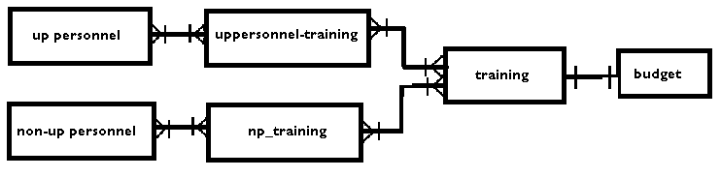
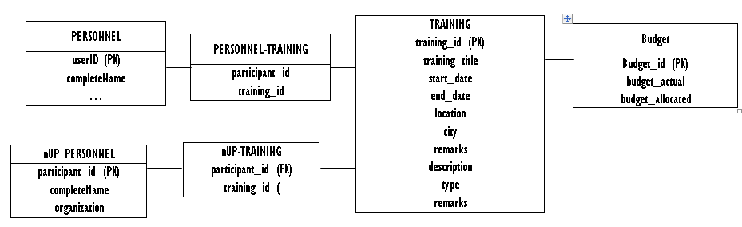
Figure 2 Detailed ERD
This diagram shows the relationship between entities given their respective cardinalities. A participant, from UP or not from UP, may have none or many trainings. A training is attended by at least one personnel. A budget has a one-to-one relationship with the training.

This Entity Relationship Diagram shows each entity with their respective attributes and other specifics.
- PARTICIPANT – entity for the university faculty or staff
- NON-UP PARTICIPANT – entity for event participants which are not from UP
- TRAINING – defines the workshop, seminar, conferences, etc.
- BUDGET– defines the money matters of an event
- PARTICIPANT – TRAINING – bridge table for the personnel and the training. This shows the link between the personnel and the training

LOGGING IN
To log in, type in your Username and Password in their corresponding input boxes and then click the button with the label ‘Login’. If you want to reset the fields click the button indicating ‘Reset’.

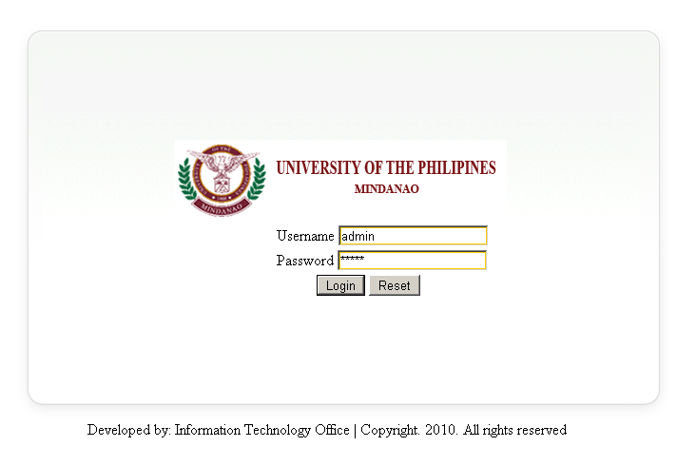
Figure 3 Login Page

After successfully logging in, click on the ‘Personnel Trainings’ button if you are an Administrator. Or the ‘My Trainings’ button if you are using the limited user type.

USER MODE
Home
- redirects to the home page. A Box containing the words MY TRAINING should be found

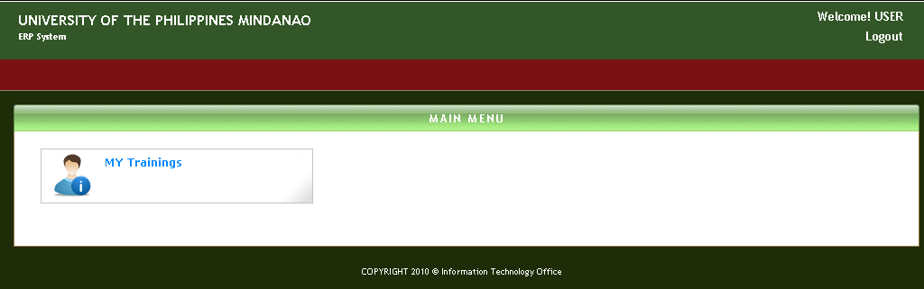
DEFAULT VIEW
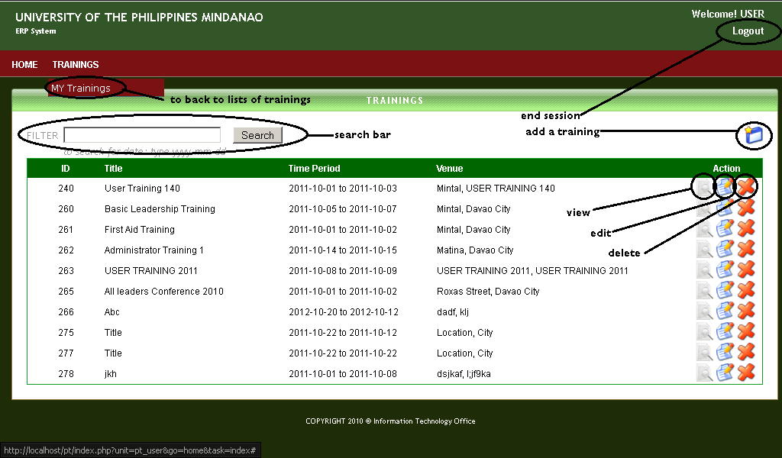
Figure 4 Default View of USER MODE: List of own trainings
Trainings
- shows a drop down having only the ‘My Training’ functionality in which if clicked redirects to a page where all the trainings of the user can be found

Search Bar
- searches the whole database’s attribute’s value: from the visible ‘TRAINING ID’, ‘TRAINING TITLE’, ‘TIME PERIOD’ and ‘VENUE’ ( that can be found as a default view when either MY TRAINING is clicked) , to the other attributes hidden and can only be seen if clicked the ‘VIEW DETAILS’ button

Add Button
- redirects to a page that looks like this one (refer below) and either saves to the database the inputted info, or just cancels the addition of entry to the database: all depends on the user’s decision
Can be done in 2 ways
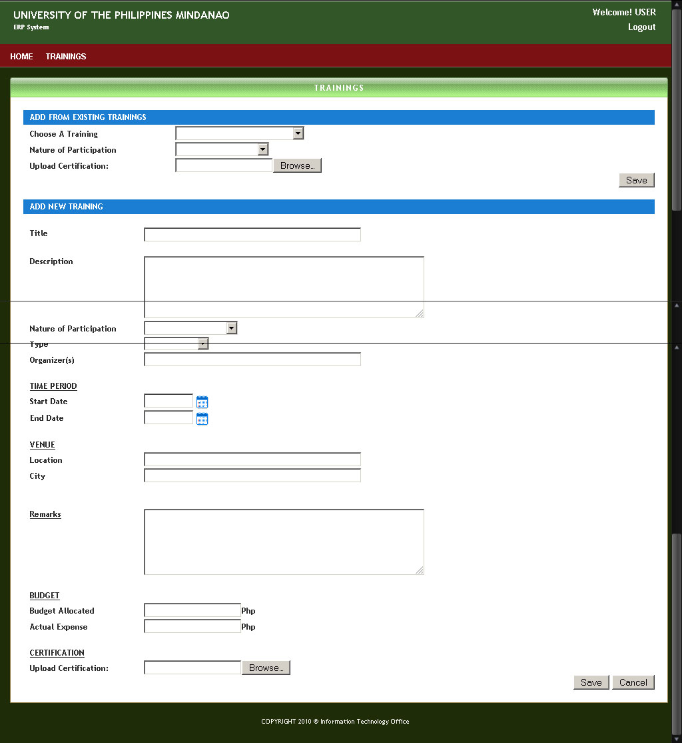
Figure 5 Add Training
ADD FROM EXISTING TRAINING
- add only the user’s ID to the database making the user a participant of the selected existing training. A certification in either .jpg .jpeg .png .pdf .bmp is strictly required.

ADD NEW TRAINING
- creates a new training ( that means no entries have been left empty ) then add the user’s ID to the newly created training. A certification in either .jpg .jpeg .png .pdf .bmp is strictly required.

VIEW DETAILS
- views the complete detail of the selected training: an example view is shown below
- this function also has branch functions namely the PRINT, EDIT and VIEW CERTIFICATE
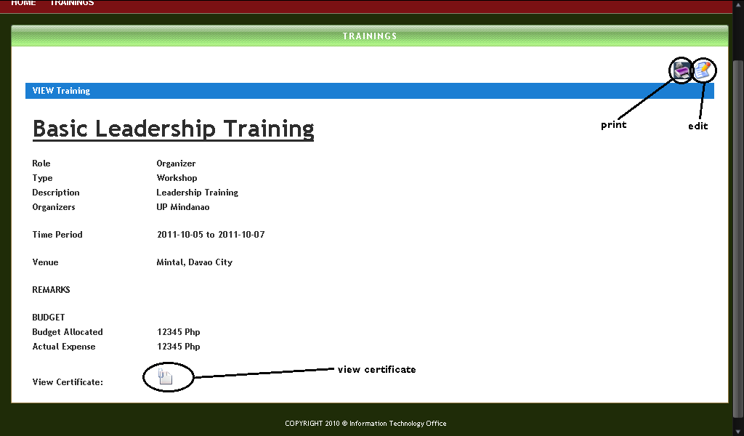
Figure 6 View Details of a Training

PRINT
- print is a built in function having web browser issues. Firefox and Internet Explorer works perfectly, while the GOOGLE CHROME browser creates error

View Certificate
- same as the PRINT function, the view certificate is a modified built in function, thus making it also to have WEB BROWSER COMPATIBILITY ISSUES. It works perfectly on GOOGLE CHROME and the INTERNET EXPLORER, but has Minimal problem when it comes to FIREFOX.
Note:
We strongly suggest using the INTERNET EXPLORER when using our modules.

EDIT
- this function redirects to a page where in the stored values for a given training is shown in an editable form

DELETE
- deletes the user’s ID on the list of people who have participated on the training

ADMIN MODE
Home
- redirects to the home page. A Box containing the words ‘PERSONNEL TRAININGS’ should be found
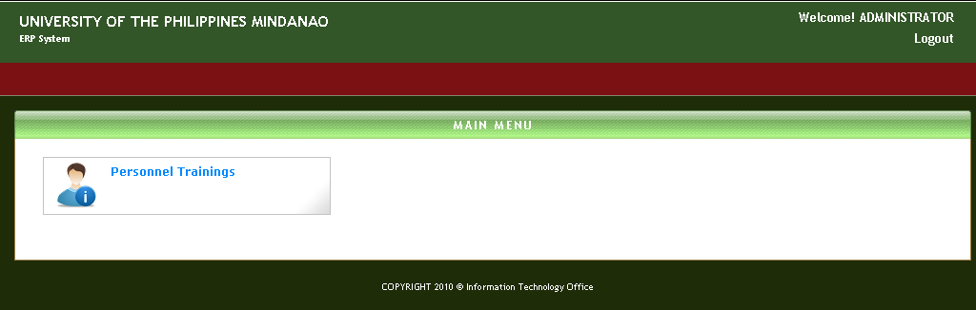
Figure 7 Admin Mode
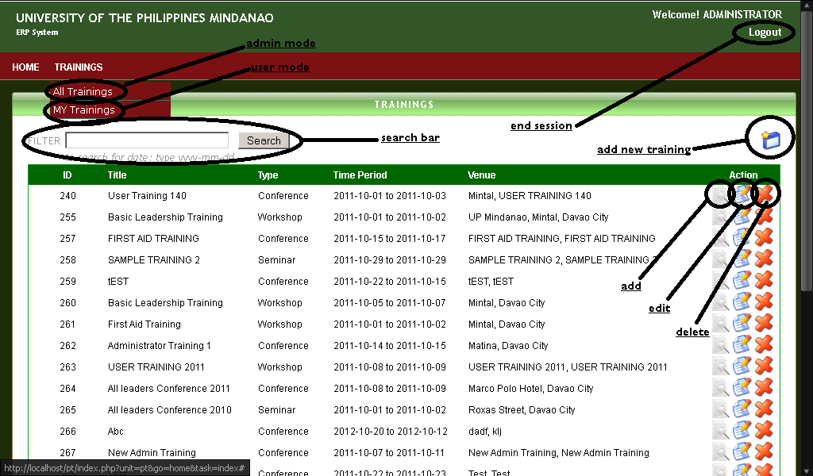
Figure 8 Default View of Admin Mode: List of all Trainings
Trainings
- shows a drop down having the ‘All Training’ and ‘My Training’ functionalities. If the ‘All Training’ is clicked, it will redirects to a page where all the trainings stored in the database can be found. And if the case that the ‘My Training’ is clicked, it will redirects to a page where all the trainings of the user can be found and the functions of the buttons are just the same on the USER MODE.
( just refer above for the USER MODE FUNCTIONALITIES )

Search Bar
- searches the whole database’s attribute’s value: from the visible ‘TRAINING ID’, ‘TRAINING TITLE’, ‘TIME PERIOD’ and ‘VENUE’ ( that can be found as a default view when either MY TRAINING is clicked) , to the other attributes hidden and can only be seen if clicked the ‘VIEW DETAILS’ button

Add Button
- redirects to a page that looks like this one (refer below) and either saves to the database the inputted info, or just cancels the addition of entry to the database: all depends on the user’s decision
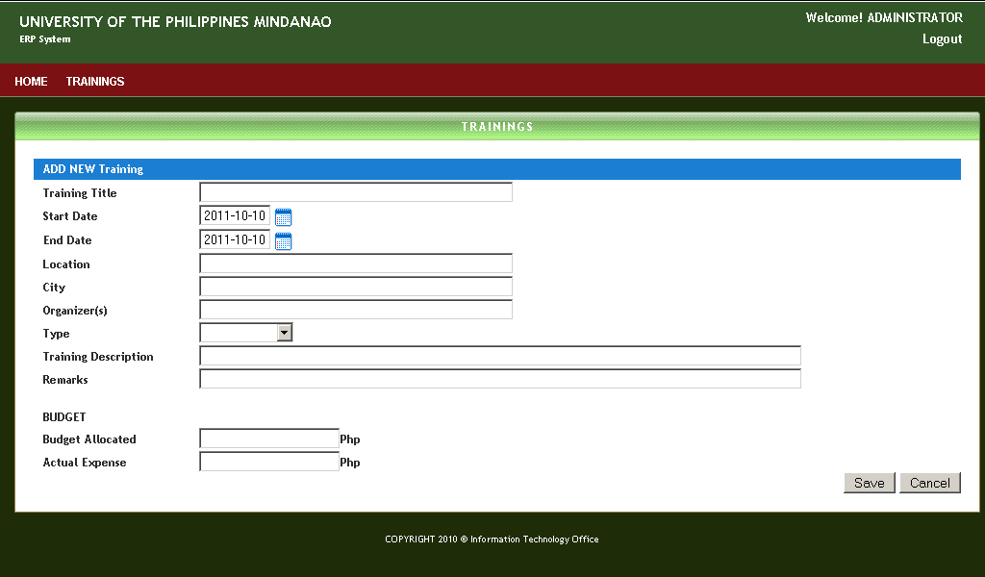
Figure 9 Add A training on Admin Mode

ADD NEW TRAINING
- creates a new training (that means no entries have been left empty). But, unlike the USER MODE, after creating the new training, it doesn’t put the manipulating

VIEW DETAILS
- views the complete detail of the selected training: an example view is shown below
- this function also has branch functions namely the PRINT, EDIT, VIEW CERTIFICATE and ADD a non-UP Participant
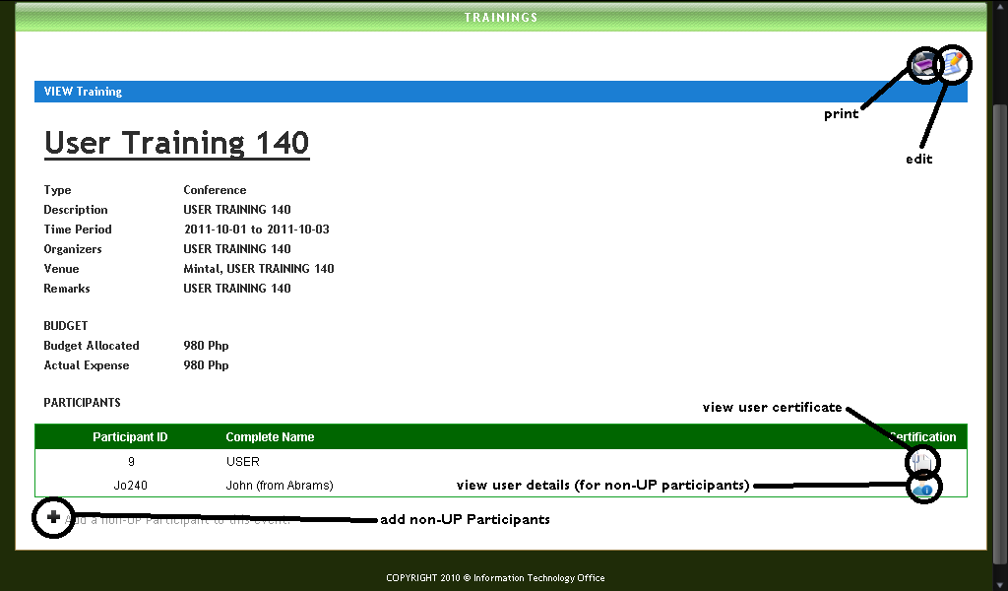
ADD A NON-UP PARTICIPANT
      - Add a non-up participant to the event.

PRINT
- print is a built in function having web browser issues. Firefox and Internet Explorer works perfectly, while the GOOGLE CHROME browser creates error

View Certificate
- same as the PRINT function, the view certificate is a modified built in function, thus making it also to have WEB BROWSER COMPATIBILITY ISSUES. It works perfectly on GOOGLE CHROME and the INTERNET EXPLORER, but has Minimal problem when it comes to FIREFOX.
Note:
We strongly suggest using the INTERNET EXPLORER when using our modules.

EDIT
- this function redirects to a page where in the stored values for a given training is shown in an editable form

DELETE
- deletes completely the information about the training, along with the detachment of the user’s ID found to be part on the list the list of people who have participated the training: DESTROYS THE TRAINING COMPLETELY.

LOGGING OUT
To logout, click the ‘Logout’ located below the complete name of the user on the upper right of the page.